



**STRUKTUR DATA**

**Kelas : CS-39-02**

**Nama : Salma**

**NIM : 1302154158**

//1302154158//SALMA//

#include "stack.h"

void createEmpty(Stack *S){

(*S).top=NULL;

}

address alokasi(int noPegX, char* namaX, int gajiX){

address p=(address)malloc(sizeof(b1));

if(p!=NULL){

(*p).noPeg=noPegX;

(*p).nama=namaX;

(*p).gaji=gajiX;

}

return p;

}

void dealokasi(address p){

free(p);

}

boolean isEmpty(Stack S){

return (S).top==NULL;

}

void pushAddress(Stack *S, address p){

(*p).next=(*S).top;

(*S).top=p;

}

void push(Stack *S, int noPegX, char* namaX, int gajiX){

address p=alokasi(noPegX,namaX,gajiX);

pushAddress(S,p);

}

void pop(Stack *S, int *noPegX, char* namaX, int *gajiX){

address p=(*S).top;

*noPegX=(*p).noPeg;

strcpy(namaX,(*p).nama);

*gajiX=(*p).gaji;

(*S).top=(*p).next;

dealokasi(p);

}

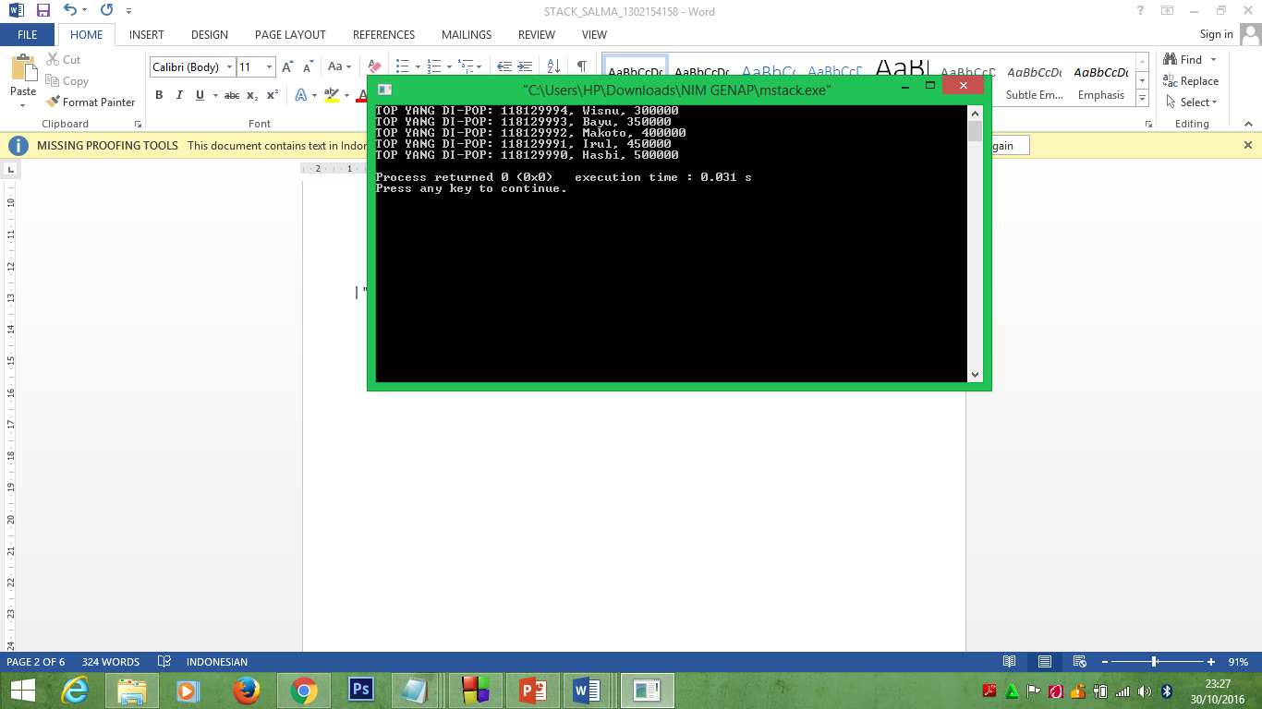

+===================================================================+

| "Saya mengerjakan tugas ini dengan jujur dan tidak melakukan pelanggaran aturan dari IFLAB. |

| Jika saya terbukti melanggar, maka saya bersedia menerima sanksi yang berlaku." |

+====================================================================+

**SOAL BONUS**

1. **HEADER**

#include <stdio.h>

#include <stdlib.h>

#include "boolean.h"

#ifndef stack_H

#define stack_H

typedef struct tElmtPutar *address;

typedef struct tElmtPutar {

char* huruf;

address next;

} p1;

typedef struct {

address top;

} Stack;

// HEADER PROSEDUR DAN FUNGSI

void createEmpty(Stack *S); //create stack kosong

address alokasi(char* hurufX);

void dealokasi(address p);

boolean isEmpty(Stack S);

void pushAddress(Stack *S, address p);

void push(Stack *S, char*namaX);

void pop(Stack *S, char*namaX);

#endif

1. **DRIVER**

#include <stdio.h>

#include "bonus.c"

int main()

{

Stack st;

createEmpty(&st);

address p0 = alokasi(118129990,"Doraemon mencari Nobita","Irul");

address p1 = alokasi(118129991,"Nobita mencari Doraemon","Hasbi");

address p2 = alokasi(118129992,"Catur 1 langkah","Makoto");

pushAddress(&st,p0);

pushAddress(&st,p1);

pushAddress(&st,p2);

push(&st,118129993,"Upin mencari Ipin","Wisnu");

push(&st,118129994,"Cinta itu apa???","Bayu");

char hurufTop[50];

while(!isEmpty(st)){

printf("Masukkan Huruf/n",st);

scanf("%s",&st);

pop(&st,&hurufTop);

push(&st,&hurufTop);

printf("TOP YANG DI-PUTAR: %s\n",hurufTop);

}

return 0;

}

1. **BODY**

//1302154158//SALMA//

#include "bonus.h"

// HEADER PROSEDUR DAN FUNGSI

void createEmpty(Stack *S){ //create stack kosong

(*S).top=NULL;

}

address alokasi(char* hurufX){

address p=(address)malloc(sizeof(p1));

if(p!=NULL){

(*p).huruf=hurufX;

}

return p;

}

void dealokasi(address p){

free(p);

}

boolean isEmpty(Stack S){

return (S).top=NULL;

}

void pushAddress(Stack *S, address p){

(*p).next=(*S).top;

(*S).top=p;

}

void push(Stack *S, char*hurufX){

address p=alokasi(hurufX);

pushAddress(S,p);

}

void pop(Stack *S, char*hurufX){

address p=(*S).top;

strcpy(hurufX,(*p).huruf);

(*S).top=(*p).next;

dealokasi(p);

}

+===================================================================+

| "Saya mengerjakan tugas ini dengan jujur dan tidak melakukan pelanggaran aturan dari IFLAB. |

| Jika saya terbukti melanggar, maka saya bersedia menerima sanksi yang berlaku." |

+====================================================================+